**Comp1168 Lab5 –** **MySQL Data Types and Built-in Functions**

1.Write a SELECT statement that returns these columns from the Invoices table:

The invoice_total column

A column that uses the FORMAT function to return the invoice_total column with 1 digit to the right of the decimal point

A column that uses the CONVERT function to return the invoice_total column as an integer

A column that uses the CAST function to return the invoice_total column as an integer

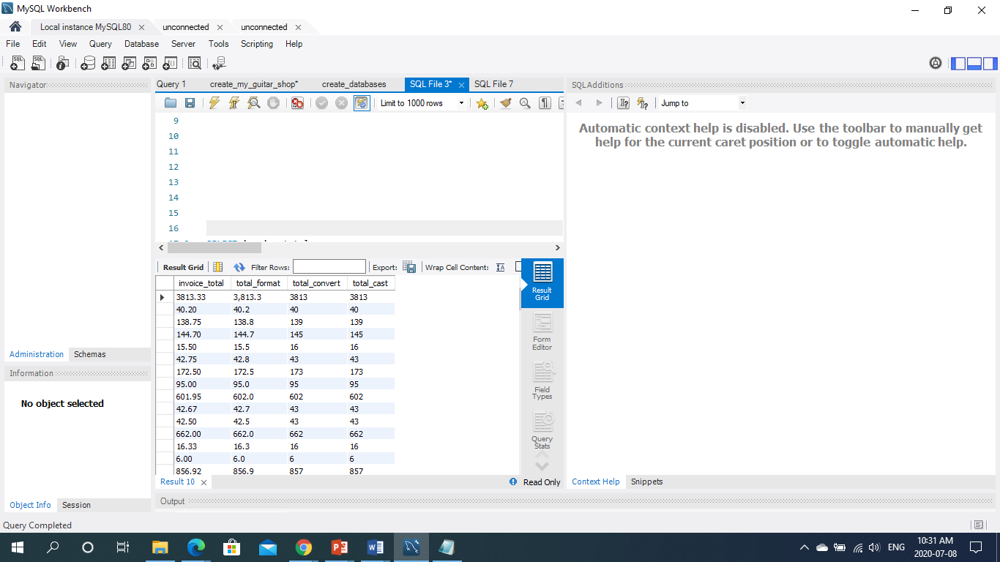

2. Write a SELECT statement that returns these columns from the Invoices table:

The invoice_date column

A column that uses the CAST function to return the invoice_date column with its full date and time

A column that uses the CAST function to return the invoice_date column with just the year

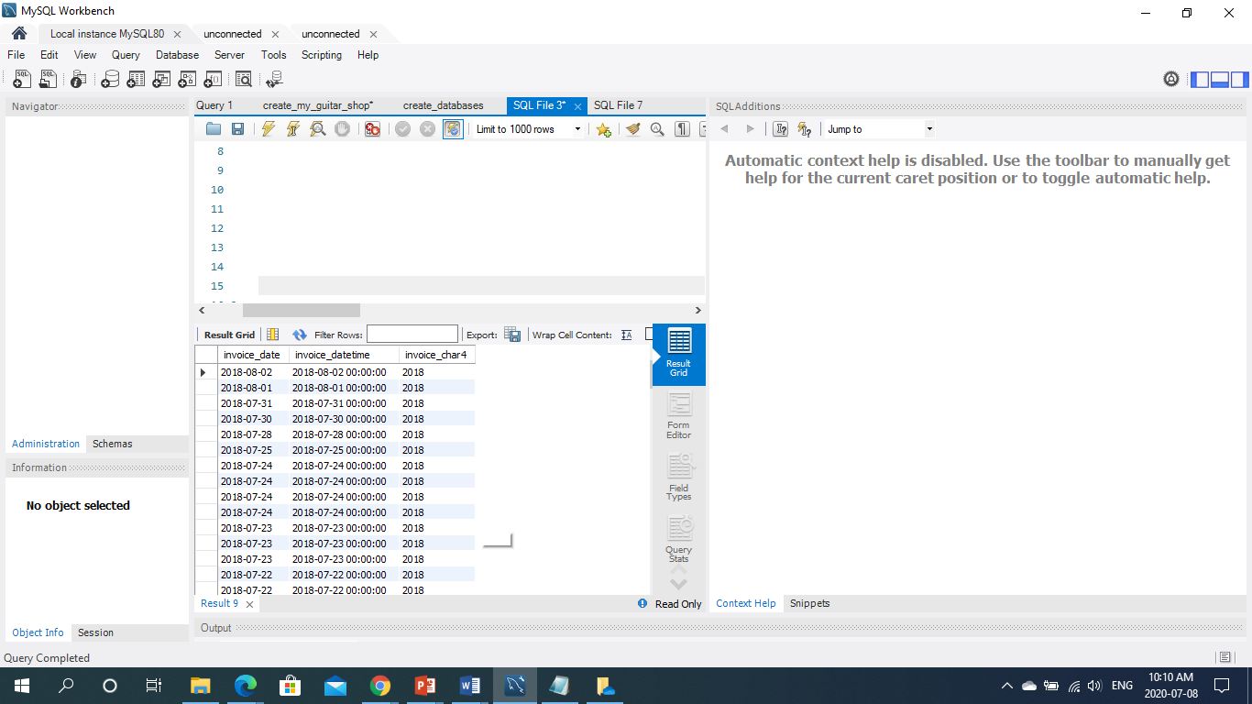

3.Write a SELECT statement that returns these columns from the Invoices table:

The invoice_total column

A column that uses the ROUND function to return the invoice_total column with 1 decimal digit

A column that uses the ROUND function to return the invoice_total column with no decimal digits

A column that uses the TRUNCATE function to return the invoice_total column with no decimal digits

